
Software Engineering Department
Braude College of Engineering
Capstone Project Phase A (61998)
CASEL in Higher Education:

AI-Guided Socratic Dialogue for Developing Social-Emotional Learning (SEL) Skills in Higher Education
CODE: 26-1-R-5
By:
Nahla Aboromy
Roba Hassan

Advisor:
Dr. Naomi Unkelos Shpigel

Link to GitHub:
https://github.com/NahlaAboromi/final_project

Table of contents:
- Abstract
- Introduction
- Literature Review
  - SEL in the Academy
  - SEL Questionnaires for Students
- Research Instruments
  - Pre/Post SEL Questionnaire
  - Simulation Scenarios
  - Reflection Questions
  - UEQ-S System Evaluation Questionnaire
- Development Process
  - Purpose of the Development
  - Requirement

Functional Requirements

Non-Functional Requirements
  - Use Case Diagram
  - Activity Diagram
  - Group Assignment and Experimental Conditions
  - Data Privacy & Anonymity Principles

Rationale for Full Anonymity

Technical Mechanisms Ensuring Anonymity

Minimal Demographic Data Collected for Research Analysis
  - System Architecture of the Experimental Module
    - Assignment Summary
    - Pre/Post Questionnaire Module

Questionnaire Structure
    - Simulation Module
      - Time Tracking for Research Analysis
    - AI CASEL Analysis Module

Purpose of the Module
    - Socratic Dialogue Module
    - AI Summary Module
    - Reflection Module
    - UEQ-S System Evaluation Module
    - Final Page Module
  - Logic Behind the Experimental Design
  - Designing the Experimental Flow

Experimental Conditions (Groups A, B, C)
    - Control Condition (Group D)
    - Ensuring Consistency and Reliability
    - Experimental Task Structure Overview
  - User Experience & Interface Design (UX/UI)
  - Deployment Strategy & Production Setup
- Pilot Study and Preliminary Evaluation
- Project metrics

  - Trust
  - Recommendations quality
  - Pre/Post SEL Questionnaire Scoring

UEQ-S System Evaluation Scoring
  - Estimated Time Requirements by Study Component
- Expected challenges
  - Users mistrust
  - Performance barriers
- References
Appendix A: Research Instrument from Ahmad & Singh (2025)
Appendix B: Full UEQ-S Questionnaire
Appendix C:Full table of functional Requirements
Appendix D:Full table of Non-Functional Requirements
Appendix E: Example of a Simulation Scenario and Research Adaptation
Appendix F: Reflection Questions Following the Socratic Dialogue

Appendix G: Additional Activity Diagrams of the Research Workflow
Appendix H: AI Development Tools, Resources, and Prompt Engineering
Appendix I: Research Specific System Interfaces and Screenshots

1. Abstract
In recent years, there has been growing recognition of the importance of Social Emotional Learning (SEL) among higher education students, due to its influence on emotional well-being, sense of belonging, and persistence in academic studies. Numerous studies indicate that SEL contributes to academic success and emotional well-being, while strengthening emotional regulation and institutional belonging. However, many students still lack access to practical, accessible, and non-judgmental opportunities to practice SEL independently of teaching staff or formal academic courses. This gap highlights the need for innovative models that do not require additional instructional resources and do not expose students to emotional vulnerability, thereby enabling more equitable responses to students’ social-emotional needs. This study examines whether a short Socratic dialogue based on Artificial Intelligence (AI) can support the development and processing of SEL skills among higher education students, without instructor intervention and without evaluative or judgmental feedback. The proposed model does not provide advice or normative answers, but instead encourages self-inquiry, emotion classification, identification of thinking patterns, and responsible decision-making, in contrast to many existing educational AI applications. The research is designed as a randomized controlled experiment including four groups: three experimental groups engaging in a short AI-based Socratic dialogue and one control group without dialogue. Participants from diverse academic fields and genders take part in an anonymous online process. All participants complete pre- and post-intervention SEL measures surrounding an authentic academic socio-emotional simulation that is consistent in structure and complexity while allowing for cultural and contextual adaptation. Only the experimental groups engage in the Socratic dialogue following the simulation. The study is expected to demonstrate that a brief, equitable, and anonymous intervention can meaningfully promote SEL. The findings may offer a language-adapted, instructor-independent model that is accessible to all students and does not require pedagogical infrastructure or professional training, thereby positioning SEL as a continuous experiential process embedded in everyday academic experiences.
Keywords: Social Emotional Learning (SEL),Socratic Dialogue,Artificial Intelligence (AI),Higher Education,CASEL.
2. Introduction
2.1 Emotional and Psychological Challenges in Higher Education
In contemporary higher education, university students face increasing emotional and psychological challenges that directly affect their capacity to learn and succeed academically. Rising levels of anxiety, depression, and loneliness, together with a diminishing sense of belonging, have been identified as major threats to students' well-being, motivation, and academic success (Conley & Donahue-Keegan, 2024). Many students experience stress, anxiety, and emotional overload as significant barriers to academic engagement, particularly when learning environments are not intentionally designed to support social-emotional resources such as self-regulation, goal setting, and meaningful interpersonal connection (DeSensi, 2024). These challenges become especially acute during high-stakes assessment periods, where students frequently report heightened anxiety, increased emotional strain, and difficulties managing academic demands factors that negatively affect both their well-being and academic performance (Simion, 2023). These findings demonstrate an urgent need for higher-education institutions to address students' emotional realities through learning environments that intentionally cultivate social-emotional skills, psychological well-being, and a sense of belonging.
2.2 SEL Interventions in Higher Education: Current Evidence
In response to these challenges, research has increasingly explored how Social Emotional Learning (SEL) can enhance students' well-being, self-regulation, and academic success. Foundational work reviewing 113 programs demonstrated that structured practice-based approaches, particularly mindfulness and guided skills training, yield stronger outcomes than didactic formats (Conley, 2015). Recent meta-analytic evidence synthesizing 32 studies found that universal SEL programs produce small to moderate positive effects on students' social-emotional competencies, attitudes, and mental health, with stronger results in smaller instructional groups (Takizawa et al., 2024). Additional research highlights that active learning, clear goals, and high-quality instruction are associated with stronger SEL profiles (Wang et al., 2025), while embedding SEL strategies within STEM curricula has enhanced students' collaboration, self-confidence, and emotional coping (Elmi, 2020). Collectively, these studies demonstrate both the promise of SEL and the importance of intentional program design in higher education.
2.3 The Gap: AI-Based Socratic Approaches
However, while existing studies demonstrate the promise of traditional SEL interventions, research on AI based approaches, particularly Socratic dialogue methods that provide personalized, scalable, and non judgmental support, remains limited. Such technology enhanced methods may offer unique advantages in accessibility, emotional safety, and individualization, addressing the need for scalable SEL solutions that do not depend on instructor availability or traditional pedagogical infrastructure.
2.4 Research Question
This study therefore addresses the following research question:
How does an AI-based Socratic dialogue influence the development of SEL skills among higher education students?
This work is structured as follows: a literature review is presented, followed by a description of research instruments and details of the system development process.
3. Literature Review
3.1 SEL in the academy
In recent years, research has highlighted the central role of Social and Emotional Learning (SEL) in higher education, emphasizing its contribution to personal development, psychological well-being, and academic success. Conley argues that systematic integration of SEL within campuses strengthens students' mental well-being, sense of belonging, and academic achievement while fostering an equitable learning environment (Conley & Donahue-Keegan ,2024). SEL functions as a preventive framework that reinforces resilience and academic motivation in response to rising anxiety and depression among students. Aligned with the CASEL model, Conley identifies five core competencies—self-awareness, self-management, social awareness, relationship skills, and responsible decision-making—as essential for navigating academic and social challenges. Empirical studies support the long-term impact of SEL. (Hareli et al. ,2025) found that integrating SEL within a career planning course yielded sustained benefits including self-discovery, emotional resilience, and interpersonal skills months after completion, suggesting that SEL is a long-term developmental process influencing professional transitions. (DeSensi ,2024) emphasizes that SEL should be embedded within course design through collaborative learning and project-based activities that cultivate belonging, emotional regulation, and resilience. Wang's systematic review (Wang D. & Ishak, 2025) demonstrates that effective SEL implementation depends on institutional support, faculty training, and culturally responsive practices. Importantly, Wang highlights the lack of frameworks for capturing how SEL competencies evolve among generations immersed in digital and AI-mediated environments. This call for updated SEL models investigating how digital platforms support or hinder socio-emotional competencies is particularly relevant to the current research, which examines an experiential AI-based SEL module within an academic learning environment.
3.2 SEL questionnaires for students
Research on Social and Emotional Learning (SEL) in higher education has highlighted the importance of assessing students' socio-emotional skills through validated questionnaires. These tools measure key competencies such as self-awareness, self-management, social awareness, relationship skills, and responsible decision-making, allowing researchers to identify students' strengths and areas for growth while informing targeted interventions. (Ahmad and Singh ,2025) examined SEL awareness among 300 undergraduates at a Malaysian public university using a CASEL-based questionnaire. Their results showed that students demonstrated strengths in social awareness and relationship skills, but revealed gaps in self-management and responsible decision-making. They emphasized that SEL contributed to emotional resilience, academic performance, and workforce preparation, while noting limitations related to convenience sampling and self-reported data. Similarly, (Ren et al. ,2025) investigated the impact of SEL on mental health among 600 students at Henan University, finding that SEL significantly improved students' mental health and coping abilities, with self-awareness, self-management, and responsible decision-making particularly linked to reduced emotional and psychological imbalance.(Johnson ,2020) further demonstrated the value of validated questionnaires in evaluating SEL outcomes through a mixed-methods pre-test/post-test study involving an SEL intervention group and a control group. The SEL program, delivered over several weeks, included workshops on emotion recognition, empathic communication, conflict resolution, and reflective practice. Results showed that intervention participants exhibited significant improvements in emotional regulation, interpersonal skills, well-being, and management of academic stress compared to controls, reinforcing that structured SEL programs effectively support students' personal growth and academic functioning.
4. Research Instruments
4.1 Pre/Post SEL Questionnaire
The Pre/Post SEL Questionnaire is one of the primary research instruments in this study and serves as the main quantitative tool for assessing university students’ social emotional competencies before and after the intervention. Its purpose is to detect potential changes in CASEL related skills as a result of the experimental process. The instrument is based on the validated SEL Skills Survey used in (Ahmad and Singh ,2025), maintaining its original structure and balanced representation of the five CASEL domains, thereby ensuring measurement reliability, academic rigor, and alignment with existing empirical literature on SEL in higher education. The questionnaire comprises 20 short statements evenly distributed across the competencies of self awareness, self management, social awareness, relationship skills, and responsible decision making, each rated on a four point Likert scale ranging from Strongly Disagree to Strongly Agree. The full list of items is provided in Appendix A. The instrument is administered at two time points, at the beginning of the study to establish an objective baseline and at the end of the participation period to evaluate changes in SEL levels. Using the same validated questionnaire in both stages enables reliable examination of Pre and Post differences, comparison between experimental and control groups, and accurate assessment of the intervention’s impact. This questionnaire forms the foundation of all quantitative analyses in the study and constitutes a central component of the overall research design.
4.2 Simulation Scenarios
The simulation scenarios were designed to create an authentic context reflecting real social emotional situations from students’ lives. Each scenario represents a realistic academic or interpersonal challenge, encouraging natural and spontaneous responses, thereby enhancing relevance to participants’ everyday experiences and providing a meaningful foundation for CASEL based analysis. Each research group was assigned a dedicated scenario that differed in content while remaining identical in structure, complexity, and activated CASEL competencies, ensuring methodological consistency across groups. The scenarios were selected from authentic and publicly available sources describing realistic student life situations, including interpersonal conflicts and academic challenges. Some scenarios, including the example presented in this study, were originally published by East Carolina University (2020) as part of an official conflict scenario training worksheet, while others were drawn from similar public sources. Each scenario underwent a research adaptation process to ensure activation of all five CASEL competencies: self awareness, self management, social awareness, relationship skills, and responsible decision making. The adaptation focused on adding missing emotional and cognitive elements while preserving the original structure, realism, and narrative fidelity. A fixed scenario was assigned to each group in advance to ensure consistent exposure across participants. An example of a simulation scenario, including the original version and the research adapted version, is provided in Appendix E.
4.3 Reflection Questions
Following the Socratic dialogue, participants in the experimental groups are presented with two open ended reflection questions designed to encourage deeper emotional and cognitive processing. The first question invites participants to consider in what way the Socratic conversation helped them reflect on their thoughts or feelings. The second question asks participants to evaluate whether talking with the AI coach was useful or meaningful to them, with space to explain their response. Both questions are intentionally phrased in a respectful and non judgmental manner, creating a safe and calm space where participants can express their thoughts honestly without fear of evaluation or grading. This reflection phase serves multiple purposes: it supports inner processing, strengthens self awareness, and provides valuable qualitative data for the study, particularly regarding the potential contribution of the Socratic dialogue to participants' social emotional learning. The full wording of the reflection questions is provided in Appendix F.
4.4 UEQ-S System Evaluation Questionnaire
The System Experience Module (UEQ-S) serves as an external standardized instrument for evaluating participants’ user experience at the end of the experimental process. The questionnaire is based on the validated short version of the UEQ developed by (Schrepp et al. ,2017) and consists of eight bipolar adjective pairs rated on a seven-point semantic scale. It assesses two key meta-dimensions: Pragmatic Quality, which reflects clarity, ease of use, efficiency, and perceived support, and Hedonic Quality, which captures interest, creativity, novelty, and excitement. The short format was selected due to its suitability for online environments, high reliability, and effectiveness as a concise standardized usability measure. The full questionnaire is provided in Appendix B.
5. Development Process
5.1 Purpose of the Development
The purpose of the development was to create a dedicated experimental module within the web environment to support the research on Social Emotional Learning (SEL) among higher education students. This module was designed to provide a complete, authentic, and methodologically rigorous experience that addresses the specific needs of SEL research in digital environments. The module encompasses several key components: completing the same validated questionnaire (Pre/Post), based on the measurement tool presented in (Ahmad & Singh, 2025), once at the beginning of the process (Pre) and once again at its end (Post); random assignment to research groups to ensure methodological validity; engaging with a carefully designed scenario (simulation) that reflects real world social emotional challenges; and participating in a guided Socratic style conversation with the AI model that encourages reflective thinking and deeper exploration of SEL competencies. This comprehensive component was developed specifically for the experiment, with particular attention to creating an environment that closely mirrors authentic social emotional learning situations while maintaining the scientific rigor required for valid research outcomes. The development aimed to enable consistent, controlled, and reliable data collection for evaluating students' CASEL competencies, specifically self awareness, self management, social awareness, relationship skills, and responsible decision making, and supporting the overall research process. By integrating these elements into a single cohesive platform, the module facilitates a seamless research experience that minimizes technical barriers, reduces potential confounding variables, and ensures that all participants encounter standardized conditions regardless of their assigned research group. Furthermore, the module was built with scalability and flexibility in mind, allowing for potential adaptations to different educational contexts, varying participant populations, and future research iterations that may explore additional dimensions of social emotional learning in higher education settings.
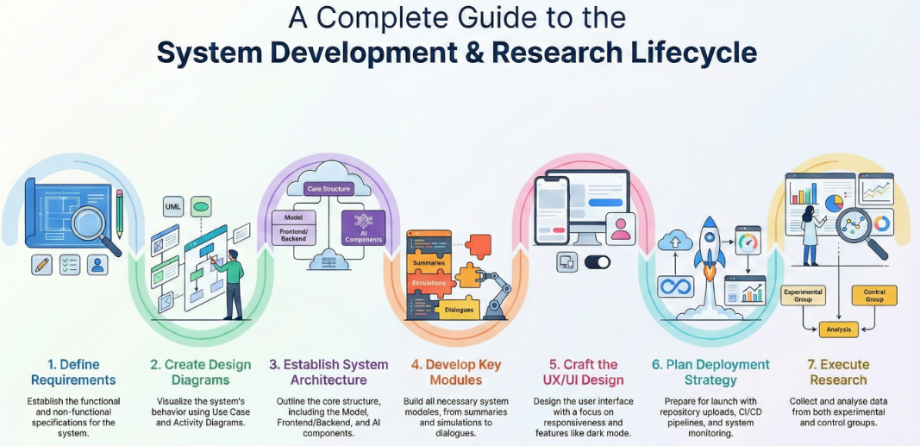
Figure 1. The engineering process

5.2 Requirement

5.2.1 Functional Requirements
No. | Requirement
1 | The system will allow users to fill in demographic data.
2 | The system will assign participants to one of the research groups (A, B, C, D).
3 | The system will allow measuring the time the user takes to complete the process from start to finish.
4 | The system will present a CASEL questionnaire both at the beginning (Pre) and at the end (Post).
5 | The system will display to each group a simulation
6 | The system will allow measuring the time it takes the user to complete the simulation.
7 | The system will analyze the user's answers.
8 | The system will allow users to interact with a Socratic coach in a guided session.
Table 1. Functional Requirements Overview.

5.2.2 Non-Functional Requirements
No. | Requirement | type
1 | All page transitions or page loads on the website will be completed in under two seconds for every user. | performance
2 | The users will be able to submit their simulation answer and receive an analysis immediately, within a maximum of 15 seconds. | performance
3 | The users will receive a response from the AI Socratic Coach within five seconds for each message during the conversation. | performance
4 | All participant data will be stored anonymously using system-generated UUID. | Security
5 | The system is available for users at least 99% of the time. | Availability
table 2. Non-Functional Requirements Overview.
5.3 Use Case Diagram
The Use Case Diagram provides a graphical representation of all possible interactions between participants and the CASELy research module. The diagram presents two main actors: the anonymous student in the control group and the anonymous student in the experimental group, as well as an additional system actor representing the external AI service (CASELy AI System). Each actor is connected to the use cases they are able to perform within the research system. By linking each actor to their corresponding use cases, the diagram clearly highlights the differences between the experimental and control conditions, as well as the distinct capabilities available to each type of participant in the system.
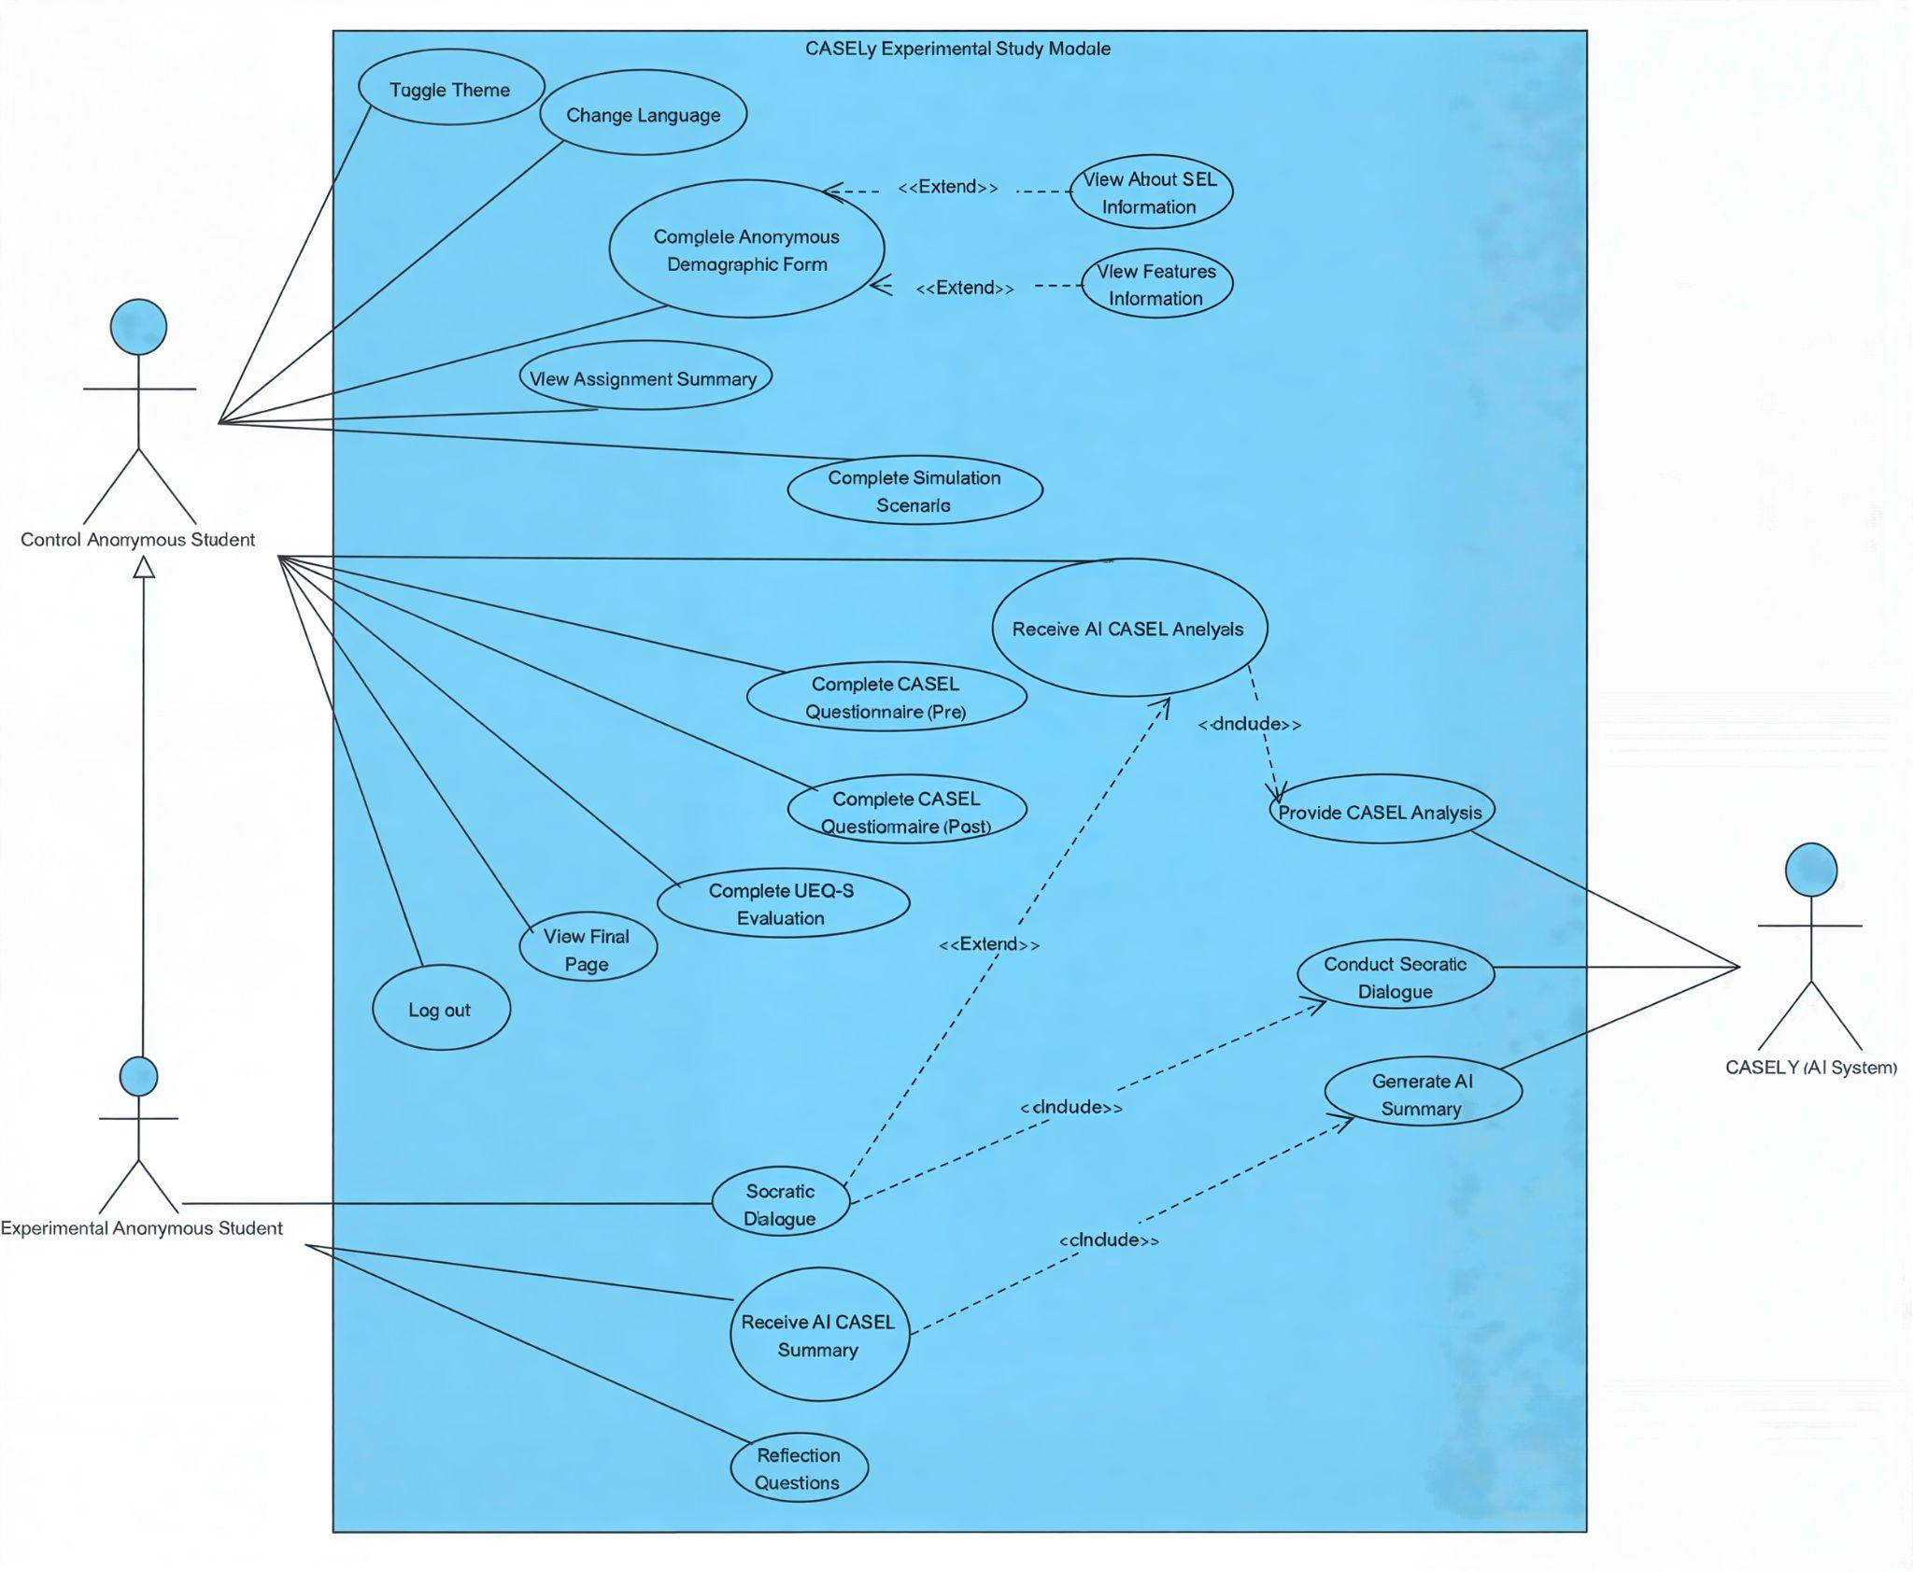
Figure 2. Use Case Diagram
5.4 Activity Diagram
The activity diagram focuses on the initial stage of the research process, from participant entry into the system to the completion of the Pre-CASEL questionnaire. It illustrates anonymous data collection and random assignment to the control group (D) and experimental groups (A, B, and C). Additional activity diagrams describing later stages of the research workflow are provided in Appendix G.
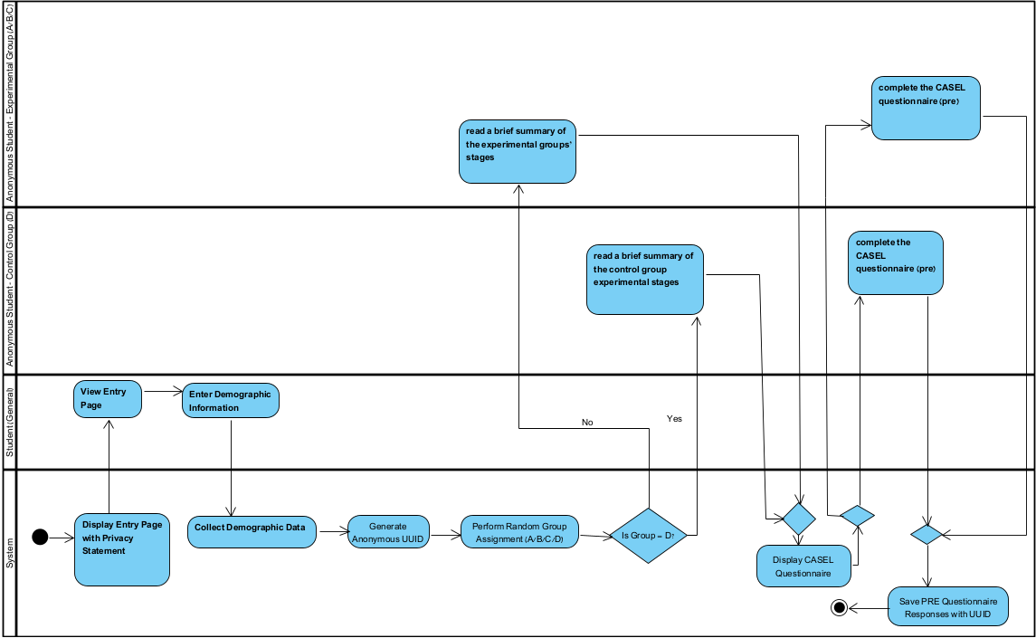
Figure 3. Entry and Pre-CASEL Questionnaire Phase of the Experimental Workflow
5.5 Group Assignment and Experimental Conditions
In the experimental phase, participants were randomly assigned to four research groups in an equal 1:1:1:1 ratio, with no option to choose their own group. Three groups (A, B, and C) served as experimental conditions, while one group (D) served as the control condition.
The choice of full randomization, together with preventing participants from selecting their group, was intended to eliminate potential bias and ensure equal research conditions for all participants. This approach avoids situations in which participants might classify themselves based on personal preference or prior expectations, which could threaten the internal validity of the study.
All groups followed the same basic structure: completing a validated questionnaire at the beginning of the process, engaging with a scenario (simulation), and completing a second validated questionnaire at the end. The only difference between the conditions occurred during the conversation stage: the experimental groups participated in a guided Socratic-style conversation with the AI model, whereas the control group did not receive this conversation.
The purpose of this division was to examine whether the Socratic dialogue influenced students’ CASEL competencies and the changes observed between the pre and post questionnaire scores.
5.6 Data Privacy & Anonymity Principles
Data privacy and anonymity were central considerations in designing the experimental module.
Because the study involves personal reflections and social-emotional responses, the system was built to ensure complete anonymity, with no possibility of linking responses to any participant’s identity.

5.6.1 Rationale for Full Anonymity
The decision to maintain full anonymity was made to reduce participant bias and encourage more honest and reliable responses. In addition, strict ethical standards were followed, avoiding any collection of identifying information to protect participants’ privacy and increase their comfort and trust.

5.6.2 Technical Mechanisms Ensuring Anonymity:
The system collects no identifying information at any stage. All data is stored under a randomly generated anonymous UUID, and the demographic form includes only non-identifying ranges. Research data is fully separated from any user system and used exclusively for research purposes. On the entry page, participants are informed: “Your data is completely anonymous. We do not collect names, emails, or any identifying information. Responses are used solely for research to improve SEL learning tools.”

5.6.3 Minimal Demographic Data Collected for Research Analysis
To support the analytical needs of the study, only four non-identifying demographic fields were collected: Field of Study, Current Semester, Age Range, and Gender. These provide essential research context and allow basic group comparisons, while ensuring full participant anonymity—no personal identifiers (names, emails, phone numbers, or student IDs) were collected.
5.7 System Architecture of the Experimental Module
The architecture of the experimental module was designed to support a comprehensive, controlled, and reliable research process that integrates quantitative measurement, qualitative evaluation, and an interactive WEB based environment. The architectural structure ensures that each participant progresses through a unified, linear, and closed process, fully aligned with the research condition to which they were assigned (experimental or control).
The module consists of several sub systems (Modules), each serving a specific function within the research workflow from presenting validated questionnaires, to delivering social emotional simulations, to generating advanced AI based analyses and facilitating an interactive Socratic conversation. The integration of these modules enables systematic tracking of each participant’s progression, ensures consistency across research groups, and supports efficient management of Pre/Post data, reflection inputs, and in depth analyses.
The system is designed so that each module operates independently while interfacing with the project’s core components: the user interface (Frontend), the processing and data handling server (Backend), and the AI engine integrated into the experimental process. This structure enables:Consistent and standardized data collection,Prevention of skipping or reordering experimental steps,Display of content tailored to each participant’s research condition and Controlled activation of the AI module according to experimental requirements
This architecture provides a robust research infrastructure that ensures all Pre/Post questionnaire data, simulation responses, CASEL analyses, Socratic dialogues, and reflection entries are collected systematically, reproducibly, and reliably an essential requirement for evidence-based academic research.
5.7.1 Assignment Summary Module
The Assignment Summary page module is designed to provide each participant with a clear and personalized overview of all the stages they will complete as part of the experiment. This module is activated immediately after the participant is randomly assigned to a research group (A/B/C or D), and its purpose is to clarify the structure of the task, the required sequence of steps, and the actions expected in each group.
The content of this page is adapted to the participant’s research condition:
Participants in the experimental groups (A/B/C) see a process that includes the Pre CASEL questionnaire, simulation, CASEL analysis, Socratic conversation, AI summary, Post CASEL questionnaire, system experience questionnaire (UEQ-S), and reflection;
Participants in the control group (D) see a shorter process that includes the Pre CASEL questionnaire, simulation, CASEL analysis, Post CASEL questionnaire, and system experience questionnaire (UEQ-S) only.
This module serves as an essential UX layer, guiding the participant and helping them understand their “research journey” in advance. In addition, the introductory page clearly displays the privacy statement, informing participants that no identifying information is collected and that all data gathered is anonymous and used solely for research purposes.
5.7.2 Pre/Post Questionnaire Module
In the system implementation, the questionnaire module is displayed only after the participant has completed all required steps according to their assigned research condition. This mechanism ensures that the questionnaire consistently appears at the correct point in the experimental flow, enabling accurate and standardized data collection. The module includes system-level controls that guarantee the presentation of identical questions in both the Pre and Post stages, uniform data formatting suitable for statistical processing, and prevention of skipping mandatory items. This design supports a fully controlled linear progression and forms the foundation for all quantitative analyses in the system. Following this, the structure of the questionnaire is presented below.

5.7.2.1 Questionnaire Structure:
The Pre/Post questionnaire includes 20 short statements, each measuring one of the five CASEL competencies. Items use a 4-point Likert scale (Strongly Disagree to Strongly Agree) presented as color-coded buttons. Statements are evenly distributed across all CASEL domains, enabling reliable measurement of self-awareness, self-management, social awareness, relationship skills, and responsible decision-making. Examples include: “Self Awareness – I am aware of my emotions,” “Self Management – I can set goals for myself,” and “Responsible Decision Making – I consider consequences before deciding.” This structure ensures consistency, usability, and clear interpretation for valid Pre/Post comparisons.
5.7.3 Simulation Module
The Simulation Module is a core component of the experimental system and is responsible for presenting a social-emotional scenario to each participant according to their assigned research group (A/B/C/D). In terms of system development, the module ensures that Each participant views only the scenario associated with their group, reads a short narrative describing a social-emotional situation, provides an open-ended written response describing how they would think, feel, or act in that situation, and submits their response for AI-based CASEL analysis in the next stage.
To preserve the validity of the experimental flow, participants cannot skip this stage, as their simulation response directly feeds into subsequent system components—the AI-generated CASEL Analysis, and for experimental groups only, the guided Socratic Dialogue. Thus, the Simulation Module serves as a structural anchor in the system workflow, ensuring a controlled, linear, and consistent research process across all participants.
5.7.3.1 Time Tracking for Research Analysis
During the simulation stage, the system automatically records the participant’s entry time and submission time. These timestamps support later statistical analyses, such as examining response duration and engagement patterns.
5.7.4 AI CASEL Analysis Module
The AI CASEL Analysis Module is a central component of the experimental system and is responsible for converting each participant’s open-ended simulation response into a structured evaluation aligned with the five CASEL competencies: self-awareness, self-management, social awareness, relationship skills, and responsible decision-making. This module forms the bridge between the qualitative phase (free text response) and the quantitative phase (scores, metrics, comparative analysis).

5.7.4.1 Purpose of the Module
The module generates a standardized and fully structured assessment that includes a score (1–5) for each CASEL competency, written feedback for each CASEL competency, strengths and areas for improvement, overall score, depth-level estimation, red flags, and suggested educational intervention. A key development consideration is language sensitivity, as participants may respond in either Hebrew or English. The AI is therefore instructed to analyze and produce all output entirely in the participant's language, ensuring naturalness, consistency, and enhanced reliability of the responses within the research context.
5.7.5 Socratic Dialogue Module
The Socratic Dialogue Module is available only to the experimental groups (A/B/C). Its purpose is to provide a short reflective conversation following the participant's simulation response and AI-generated CASEL analysis. The module engages the participant in a guided, Socratic-style dialogue designed to deepen emotional awareness, clarify reasoning, and encourage self-reflection. The module follows the principles of the Socratic method: one short question at a time, no advice-giving, no judgment, and no direct answers, a warm, calm and supportive tone, language matching the participant (Hebrew or English), and questions based strictly on the participant's written response and the CASEL analysis. To maintain methodological consistency, the module follows four key development principles. First, it is based strictly on participant input—the AI does not invent details, expand the scenario, or introduce new information, and every question is grounded in the participant's own words and the CASEL analysis summary. Second, it presents one question per turn, which ensures a natural dialogue flow and prevents cognitive overload. Third, it encourages independent reflection—the AI never tells the participant what to do, but instead nudges the participant to articulate their own thoughts, feelings, and values. Fourth, it employs subtle activation of CASEL dimensions—the dialogue gently prompts consideration of self-awareness, self-management, social awareness, relationship skills, and responsible decision-making, but without naming CASEL explicitly. The conversation flow consists of three phases: an opening with one short question based on a single insight from the analysis, a middle section consisting of a natural back-and-forth dialogue lasting approximately 7–8 minutes, and a closing with a brief reflective question such as "What is one thing you learned about yourself?" This module was designed to create a controlled, consistent, and emotionally meaningful reflective experience, enabling us to examine the impact of short Socratic dialogue on participants' CASEL development.
5.7.6 AI Summary Module
The AI Summary Module is activated immediately after the Socratic dialogue to provide the participant with a warm, personal summary based on the simulation, reflection question, and interaction with the Socratic coach. The system generates a short description in the participant’s language, adapting tone and style to their natural writing. The algorithm creates an empathetic, direct, second-person message that reflects the participant’s thoughts, feelings, or themes without judgment or third-person phrasing. The goal is to strengthen the participant’s sense of being seen and understood, acknowledge their effort, and offer a moment of emotional processing before continuing to the next stages of the study, serving as a gentle, supportive bridge between the dialogue phase and the continuation of the research process.
5.7.7 Reflection Module
The Reflection Module provides participants with a final opportunity to pause, process, and reflect on the experience they went through during the study. This module is shown only to participants in the experimental groups (A/B/C), after they have completed all stages of the intervention. Once all stages are completed, the participant is presented with the reflection questions within the system interface. The module ensures that the reflection stage appears only at the correct point in the experimental flow and that responses are submitted successfully as part of the system’s data collection process.
5.7.8 System Experience Module (UEQ-S)
The System Experience Module (UEQ-S) was integrated into the system as the final stage before the closing page and is displayed automatically to all participants, regardless of research group. From a development perspective, the module is triggered only after the participant has completed all required stages of the experimental flow (including questionnaires, simulation, analysis, and the Socratic dialogue for experimental groups), ensuring a linear and controlled workflow. The interface presents the eight bipolar adjective pairs on a seven-point semantic scale and requires participants to select one response per item before submission. The module includes validation mechanisms that prevent skipping any items, as well as a structured data-collection process that stores all responses for later statistical analysis. Integrating the UEQ-S into the system provides a consistent and standardized measure of overall user experience while preserving full alignment with the experimental design.
5.7.9 Final Page Module
The Final Page Module serves as the official closing stage of the process. It thanks the participant for contributing to the study, reinforces their sense of value, and clearly restates that all collected data remain fully anonymous and are used solely for research purposes. Alongside the appreciation note, the page provides a brief technical recap, including the participant’s generated Anonymous ID and the final phase completed. The goal of this module is to conclude the experience in a positive, supportive, and transparent manner summarizing the participant’s contribution, reassuring their privacy, and signaling that the research task has been successfully completed.
5.8 Logic Behind the Experimental Design
The logic behind the experimental design is based on creating a consistent and well documented process that allows for a controlled examination of how a brief Socratic dialogue may contribute to emotional understanding, self-reflection, and social-emotional learning. The structure ensures that all participants go through the same core stages Pre questionnaire, simulation, and CASEL analysis while only the experimental groups continue to the advanced stages: the Socratic Dialogue, the AI Summary, and finally the Reflection Module. This distinction allows the study to isolate the effect of the intervention (the Socratic dialogue and its follow up processing) and compare outcomes reliably between the experimental and control groups.
The linear design allows each stage to build meaningfully on the previous one. The simulation first provides an authentic emotional experience that fosters personal engagement. This is followed by the CASEL analysis, which offers a cognitive framework for understanding the participant’s response. The subsequent Socratic dialogue deepens both emotional and cognitive processing of the experience, while the AI summary provides a warm and supportive sense of closure. Finally, the Reflection Module enables participants to articulate, in their own words, the meaning, insights, and personal impact of the experience.
In addition, the design includes random assignment to groups A/B/C/D, along with a predefined mapping of each group to a specific scenario. This ensures consistency, transparency, and a clear separation between experimental and control conditions.
Ultimately, this structure allows for a precise examination of whether — and how — a brief Socratic conversation and its follow-up processing, following an emotionally engaging scenario, influence self-awareness, emotional regulation, and reflection when compared to a process that does not include any dialogic component.
5.9 Designing the Experimental Flow
To ensure that the experimental process is clear, consistent, and reliable for all participants, a linear and closed Flow was designed in the web system.
Before beginning the task, each participant is presented with an introductory page (“Assignment Summary”), summarizing all the steps they are about to complete.
This page improves the user experience, provides clarity about the structure of the task, and displays only the flow relevant to the participant’s assigned condition (experimental or control).

5.9.1 Experimental Conditions (Groups A, B, C)
Participants in the experimental groups completed a structured six-stage process. First, they completed the validated CASEL questionnaire (Pre) to establish baseline measurements. Second, they engaged with a social-emotional scenario specifically assigned to their group (A, B, or C), with each group receiving a methodologically equivalent but distinct scenario as part of the controlled research design. Third, upon submitting their simulation response, participants received an AI-generated analysis evaluating their response across the five CASEL components: Self-Awareness, Self-Management, Social Awareness, Relationship Skills, and Responsible Decision-Making. Fourth, participants engaged in a guided Socratic conversation with the AI system (CASELY), which served as the main independent variable of the experiment. Fifth, participants completed the CASEL questionnaire again (Post) to measure changes relative to baseline. Sixth, following the Post questionnaire, participants responded to two open-ended reflection questions examining their experience with the Socratic conversation and its perceived usefulness. Finally, before reaching the completion page, participants evaluated the system's usability and overall user experience using the validated User Experience Questionnaire-Short (UEQ-S).

5.9.2 Control Condition (Group D)
The control group completed a simplified four-stage procedure designed to isolate the effect of the Socratic conversation intervention. Participants first completed the CASEL questionnaire (Pre), then engaged with a social-emotional scenario specifically assigned to Group D. Following their simulation response, they received an AI-generated CASEL analysis identical in structure to that provided to experimental groups. Participants then completed the CASEL questionnaire (Post) and the UEQ-S evaluation before reaching the completion page. Critically, the control group did not receive the Socratic conversation intervention and did not complete the reflection stage, allowing for direct comparison of outcomes with and without the conversational component.
5.9.3 Ensuring Consistency and Reliability
Across all groups, the flow is linear and closed, meaning participants cannot skip steps or navigate freely. This design ensures full consistency, prevents bias, and enables accurate and comparable data collection.
5.9.4 Experimental Task Structure Overview:
Table 3:Experimental vs. Control Task Structure
Step / Task | Experimental Groups (A/B/C) | Control Group (D)
Group Assignment + Introductory Page (“Assignment Summary”) | ✓ | ✓
Validated CASEL Questionnaire (Pre) | ✓ | ✓
Simulation (Scenario) + Reflection Question | ✓ | ✓
AI CASEL Analysis (5 Components) | ✓ | ✓
Guided Socratic Conversation with CASELY | ✓ | ✗
AI Summary | ✓ | ✗
Validated CASEL Questionnaire (Post) | ✓ | ✓
Reflection (Two Open Ended Questions) | ✓ | ✗
Validated UEQ-S (User Experience Short Questionnaire) | ✓ | ✓
Final Page | ✓ | ✓
5.10 User Experience & Interface Design (UX/UI)
The UX/UI design of the system was developed to create a clear and structured research experience while minimizing cognitive load, with each screen displaying only the current task. The platform provides full bilingual support (Hebrew/English), presenting all content in the participant’s chosen language. The system is also fully responsive, ensuring that all interface elements adapt smoothly across devices. The clean layout and calm visual design promote emotional safety and comfort. Overall, the interface centers the participant by offering intuitive navigation, reducing effort, and supporting a consistent and supportive research experience.
5.11 Deployment Strategy & Production Setup
The deployment phase finalized the development process by first uploading all project components to GitHub as a structured and documented central repository. Following this, the system was deployed to a dedicated production server on Contabo. Deploying on Contabo enabled the latest version of the system to run reliably, efficiently, and be fully accessible to all participants while maintaining complete anonymity, a strict linear research flow, and clear separation between experimental and control groups. The setup also supported basic monitoring, This transition from GitHub to a Contabo production environment provided a stable and dependable infrastructure that allowed the system to be used effectively in the research experiment.
6. PILOT STUDY AND PRELIMINARY EVALUATION
A pilot study with four higher education students (three experimental, one control) All students were 4th year software engineering students, ages 20-25, 3 females and 1 male. Participants perceived the system as clear and intuitive, reporting improved SEL understanding, while experimental participants particularly valued the AI-guided dialogue for reducing fear of judgment and enabling honest self-expression. Following a full run of the system (approximately 26–32 minutes for experimental participants and 14–19 minutes for the control participant), the participants evaluated system clarity, technical stability, and user experience through semi-structured interviews. Thematic analysis of pilot interviews (Figure 4) illustrates frequency and positive sentiment across categories on a radial 0–5 scale, with high positive sentiment for User Experience and SEL Learning and highest frequency for Bot Interaction, highlighting differences between dialogue and non-dialogue conditions.In addition, UEQ-S user experience questionnaire (Appendix B) results showed substantially higher pragmatic and hedonic quality scores for experimental participants (Overall = 1.50 on a standardized −3 to +3 scale, where positive values indicate better user experience) compared to the control condition (0, representing a neutral evaluation), indicating that the Socratic dialogue significantly enhances user engagement and experience.
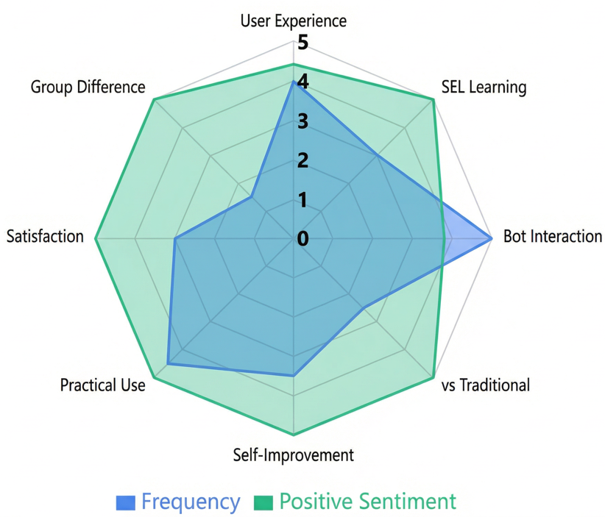
Figure 4: Thematic Analysis of Overall Pilot Study Interviews: Frequency and Sentiment Across Categories
7. Project metrics
7.1 Trust
Trust represents participants’ confidence in the AI-based system and their willingness to engage authentically in the social-emotional reflection process. Given that the intervention involves personal reflection on emotionally sensitive situations, establishing trust is essential for meaningful engagement and honest responses. Trust will be evaluated through a combination of qualitative, quantitative, and behavioral indicators. Qualitative indicators will be derived from participants’ reflective responses (Appendix F), capturing whether interactions with the AI coach are perceived as meaningful and useful. Quantitative indicators will be obtained through the Pragmatic Quality dimension of the UEQ-S questionnaire (Items 1–4), reflecting perceived system supportiveness, clarity, and reliability. Behavioral indicators of trust will be inferred from participants’ willingness to engage deeply with the simulation scenarios and to complete all stages of the experimental process. In addition, the system has been intentionally designed with trust-building mechanisms, including complete anonymity (Section 5.6), non-judgmental Socratic dialogue (Section 5.7.5), and transparent communication regarding data privacy, with the goal of creating a safe emotional space that enables open and authentic reflection without fear of evaluation or exposure.
7.2 Recommendations quality
Recommendations Quality in this study is examined in relation to how system generated outputs particularly the AI based CASEL analysis and the Socratic dialogue are experienced by participants in terms of relevance personalization and perceived meaningfulness. Rather than functioning as a conventional recommendation system that delivers direct advice or predefined solutions the CASELY system adopts a reflective approach generating questions and insights that are closely grounded in participants’ own responses and in the mapping of SEL competencies. The quality of recommendations will be evaluated based on their alignment with the participant’s personal input consistency with the CASEL framework and their capacity to foster self reflection emotional clarity and a meaningful reflective process without eliciting feelings of judgment or coercion. Viewed in this way recommendations quality reflects the system’s role as a facilitator of emotional learning rather than as an external source of knowledge and serves as a key component in assessing the effectiveness of the proposed intervention.
7.3 Pre/Post SEL Questionnaire Scoring
The Pre/Post SEL Questionnaire employs a structured scoring procedure aligned with the CASEL framework, enabling both domain specific and overall assessment of social emotional competencies. The instrument is adapted from the validated SEL Skills Survey (Ahmad & Singh, 2025) and preserves its original psychometric structure and interpretation guidelines. Participants responded to 20 items using a 4 point Likert scale ranging from 1 Strongly Disagree to 4 Strongly Agree. Each CASEL competency domain including Self Awareness, Self Management, Social Awareness, Relationship Skills, and Responsible Decision Making was represented by four items, with domain level scores calculated as the mean of the corresponding items with a possible range of 1.00 to 4.00, where higher values indicate stronger competency. An overall SEL score was computed as the mean of all 20 items, representing the participant’s general level of social emotional competence.
Table 4: Interpretation Data (Adapted from Ahmad & Singh, 2025)
Weight | Scale Range | Description | Interpretation
4 | 3.25 – 4.00 | Strongly Agree | High Level
3 | 2.50 – 3.24 | Agree | Average Level
2 | 1.75 – 2.49 | Disagree | Low Level
1 | 1.00 – 1.74 | Strongly Disagree | Very Low Level

7.4 UEQ-S System Evaluation Scoring
The User Experience Questionnaire Short (UEQ-S) was used to assess participants’ subjective experience with the experimental system, following the standardized semantic differential scoring procedures established by (Schrepp et al. ,2017). The instrument consists of eight bipolar items rated on a 7-point semantic differential scale ranging from 1 to 7, corresponding to opposing adjective pairs. Raw item scores were transformed to the standard UEQ-S scale ranging from −3 (most negative evaluation) to +3 (most positive evaluation) by subtracting 4 from each raw score, thereby centering the scale at zero. Item polarity followed the original UEQ-S specification, with all items having the positive pole on the right except the clear/confusing item, which was reverse-coded prior to transformation. Two composite dimension scores were calculated: Pragmatic Quality, computed as the mean of Items 1–4, reflecting perceived usability, clarity, efficiency, and task support; and Hedonic Quality, computed as the mean of Items 5–8, reflecting perceived novelty, stimulation, originality, and engagement. An overall user experience score was calculated as the mean of all eight transformed items, providing a holistic evaluation of the system that integrates both pragmatic and hedonic aspects of user experience.
Table 5: UEQ-S Scoring Structure and Dimensions (Adapted from Schrepp et al. ,2017)
Dimension | Items | Score Range | Description
Pragmatic Quality | Items 1–4 | −3.00 to +3.00 | Reflects perceived usability, clarity, efficiency, and task support
Hedonic Quality | Items 5–8 | −3.00 to +3.00 | Reflects perceived novelty, stimulation, originality, and engagement
Overall User Experience | Items 1–8 | −3.00 to +3.00 | Represents overall subjective evaluation integrating pragmatic and hedonic aspects
7.5 Estimated Time Requirements by Study Component
To ensure methodological transparency and to account for participant burden, estimated time requirements are provided for each stage of the research process. These estimates are based on pilot testing and system design considerations, reflecting a concise and feasible experimental procedure. Presenting task durations supports ethical informed consent and facilitates accurate study planning.
Table 6: Estimated Time Requirements by Study Component
Component | Experimental Groups (A, B, C) | Control Group (D) | Notes
Demographics & Group Assignment | 1 min | 1 min
Assignment Summary Page | 1 min | 1 min
Pre-CASEL Questionnaire | 2–3 min | 2–3 min
Simulation Scenario & Written Response | 5-7 min | 5-7 min
AI CASEL Analysis Review | 2 min | 2 min
Socratic Dialogue with AI Coach | 7–8 min | -
AI Summary Review | 1 min | -
Post-CASEL Questionnaire | 2–3 min | 2–3 min
Reflection Questions | 2 min | -
UEQ-S System Evaluation | 1–2 min | 1–2 min
Final Completion Page | 0.5 min | 0.5 min
Total Estimated Time | 26-32 min | 14-19 min
8. Expected challenges
8.1 Users mistrust
Users’ mistrust constitutes a potential challenge to authentic engagement with the AI-based intervention, particularly given the personal and emotionally sensitive nature of the social-emotional reflection process. Despite the system’s intentional trust-enhancing design, including complete anonymity, non-judgmental Socratic dialogue, and transparent communication regarding data privacy, some participants may remain hesitant to engage fully or disclose personal experiences. Such mistrust may stem from skepticism toward AI-mediated emotional support, concerns about privacy and data use, or perceptions of artificiality in automated dialogue when compared to human facilitation. Variations in cultural background, prior experience with AI systems, or individual attitudes toward technology may further influence receptiveness. These factors may affect the depth of engagement and the overall effectiveness of the reflective process, and will therefore be considered when interpreting study outcomes.
8.2 Performance barriers
Performance barriers represent another anticipated challenge, as the intervention relies on real-time AI-generated analysis and dialogue. System responsiveness, stability, and accessibility are essential for maintaining a natural reflective flow and preventing user frustration. Potential limitations include response latency, technical instability, or inconsistencies across devices, browsers, and language settings. Although the planned study involves a limited number of participants and short interaction sessions, performance constraints may still influence user experience and engagement levels. Addressing these challenges is important not only for ensuring reliable evaluation results, but also for informing future system refinement and potential deployment at a larger scale.
References
Ahmad Feisal, A. A., & Singh, S. K. S. (2025). Social and emotional learning (SEL) awareness of undergraduates in Malaysia: A case of a public university in Malaysia. International Journal of Modern Education, 7(25), 633–646. https://doi.org/10.35631/IJMOE.725043

Conley, C., & Donahue-Keegan, D. (2024). SEL for Well-Being and Equity in Higher Education.

Elmi, C. (2020). Integrating social emotional learning strategies in higher education. European journal of investigation in health, psychology and education, 10(3), 848-858.‏‏

Johnson, L. D. (2020). Social-Emotional Learning in Higher Education: A Program Evaluation (Doctoral dissertation, National Louis University). ProQuest Dissertations Publishing, 28023457.

Pham, S. V. (2024). The influence of social and emotional learning on academic performance, emotional well-being, and implementation strategies: A literature review. Saudi Journal of Humanities and Social Sciences, 9(12), 1–10. https://doi.org/10.36348/sjhss.2024.v09i12.001

Ren, J. J., Songsiengchai, S., & Yang, F. (2025). The impact of social-emotional learning (SEL) on the mental health and well-being of students at Henan University. International Journal of Education & Literacy Studies, 13(2), 666–674.

Sharmila, S., & Nandhakumar, R. ANALYSING THE EFFECTIVENESS OF SEL COMPETENCIES ON ENHANCING ACADEMIC OUTCOMES AMONG COLLEGE STUDENTS.‏

Wang, F., Zeng, L. M., & King, R. B. (2025). University students’ socio-emotional skills: The role of the teaching and learning environment. Studies in Higher Education, 50(8), 1670–1687. https://doi.org/10.1080/03075079.2024.2389447

https://advising.ecu.edu/wp-content/pv-uploads/sites/315/2020/07/M8L4-Conflict-Scenarios-Worksheet.pdf

Schrepp, M., Hinderks, A., & Thomaschewski, J. (2017). Design and evaluation of a short version of the User Experience Questionnaire (UEQ-S). International Journal of Interactive Multimedia and Artificial Intelligence, 4(6), 103–108. https://doi.org/10.9781/ijimai.2017.09.001

Wang, F., Zeng, L. M., & King, R. B. (2025). University students’ socio-emotional skills: The role of the teaching and learning environment. Studies in Higher Education, 50(8), 1670–1687. https://doi.org/10.1080/03075079.2024.2389447

Hareli, M., Knutsen, J. C., Nowakowski, L. M., Conley, C. S., & Gonzales, C. H. (2025). Infusing social-emotional skills into a career and life planning course for college adults: A qualitative analysis and quantitative summary of student perceptions at post-course and at post-college follow-up. Social and Emotional Learning: Research, Practice, and Policy, 5, 100097. https://doi.org/10.1016/j.sel.2025.100097

DeSensi, V. L. (2024). Embedding social and emotional learning (SEL) design to support college student well-being and learning outcomes: a review of the relevant literature. Journal of the National Organization for Student Success, 1(1).‏

Simion, A. (2023). The impact of socio-emotional learning (SEL) on academic evaluation in higher education. Educatia 21, 24(1), 109–117. https://www.ceeol.com/search/article-detail?id=1193955

Takizawa, Y., Matsumoto, Y., & Ishimoto, Y. (2024). Effectiveness of universal social-emotional learning programs for Japanese higher education students: A meta-analytic review. Health Open Research, 4, Article 4. https://doi.org/10.12688/healthopenres.13467.1

Conley, C. S. (2015). SEL in higher education. In J. A. Durlak, C. E. Domitrovich, R. P. Weissberg, & T. P. Gullotta (Eds.), Handbook of social and emotional learning: Research and practice (pp. 197–212). Guilford Press.

Wang, D., & Ishak, Z. (2025). Unveiling the implementation of social-emotional learning among college students: A systematic literature review. International Journal of Learning, Teaching and Educational Research, 24(5), 376–399. https://doi.org/10.26803/ijlter.24.5.20

Appendix A: Research Instrument from Ahmad & Singh (2025)
Construct | Items
Self-Awareness | [SA1] I am aware of the emotions I feel.  [SA2] I can calm myself down.  [SA3] I know what my strengths are.  [SA4] I am aware when my feelings are making it hard to focus.
Self-Management | [SM1] I can be patient during lessons that get me excited.  [SM2] I always manage to finish my tasks even if they are hard for me.  [SM3] I can set goals for myself.  [SM4] I complete my assignment even if I do not feel like it.
Social-Awareness | [SoA1] I learn from people with different opinions than me.  [SoA2] I am able to tell what people may be feeling.  [SoA3] I know when someone needs help.  [SoA4] I know how to get help when I’m having trouble with a classmate.
Relationship-Skills | [RS1] I can respect a classmate’s opinions during disagreements.  [RS2] I get along well with my classmates.  [RS3] I always speak to an adult when I have problems at school.  [RS4] I build and maintain healthy relationships within my university community.
Responsible-Decision-Making | [RDM1] I think about what might happen before making any decision.  [RDM2] In a situation, I know what is right or wrong.  [RDM3] I can strictly say “NO” to a friend who wants me to break the rules.  [RDM4] I always seek advice or feedback from others before making important decisions.

Appendix B: Full UEQ-S Questionnaire
obstructive | o o o o o o o | supportive | 1
complicated | o o o o o o o | easy | 2
inefficient | o o o o o o o | efficient | 3
clear | o o o o o o o | confusing | 4
boring | o o o o o o o | exiting | 5
not interesting | o o o o o o o | interesting | 6
conventional | o o o o o o o | inventive | 7
usual | o o o o o o o | leading edge | 8

Appendix C:Full table of functional Requirements
No. | Requirement
1 | The system will allow users to select a field of study.
2 | The system will allow users to select their current semester number.
3 | The system will allow users to choose their age range .
4 | The system will allow users to select their gender.
5 | The system will assign participants to one of the research groups (A, B, C, D).
6 | The system will display to the users a summary of all stages of the research process
7 | The system will allow measuring the time the user takes to complete the process from start to finish.
8 | The system will present a CASEL questionnaire both at the beginning (Pre) and at the end (Post).
9 | The system will allow users to answer each question in the questionnaire.
10 | The system will allow users to change their answer to any question.
11 | The system will allow users to navigate back to previous questions to modify their answers.
12 | The system will save the answers provided by the users.
13 | The system will display the questionnaire results summary.
14 | The system will display to each group a simulation
15 | The system will allow the display of questions for the simulation.
16 | The system will allow users to answer the questions.
17 | The system will allow measuring the time it takes the user to complete the simulation.
18 | The system will analyze the user's answers.
19 | The system will display the analysis results to the users.
20 | The system will allow users to interact with a Socratic coach in a guided session.
21 | The system will allow time-limited interaction with the Socratic coach.
22 | The system will display a summary of the conversation with the Socratic AI to the users.
23 | The system will display a structured reflection.
24 | The system will allow users to answer the reflection questions.
25 | The system will display a user experience questionnaire to the user.
26 | The system will allow the user to answer the experience questionnaire.
27 | The system will allow the user to send an email to a predefined address
28 | The system will support dark mode functionality
29 | The system will support two languages: English and Hebrew.
Appendix D:Full table of Non-Functional Requirements
No. | Requirement | type
1 | All page transitions or page loads on the website will be completed in under two seconds for every user. | performance
2 | Switching between design modes (dark/light mode) will occur in under one second. | performance
3 | Switching the system language (English/Hebrew) will occur in under one second. | performance
4 | The users will be able to submit their simulation answer and receive an analysis immediately, within a maximum of 15 seconds. | performance
5 | The users will receive a response from the AI Socratic Coach within five seconds for each message during the conversation. | performance
6 | All participant data will be stored anonymously using system-generated UUID. | Security
7 | The system is available for users at least 99% of the time. | Availability
8 | The system provides a clear registration process, highlighting the required fields. | Usability
9 | All questionnaires include clear descriptions of the content and instructions for completion. | Usability
10 | The system is easy to use, intuitive, and accessible for all users. | Usability
11 | The system allows users to complete the CASEL questionnaire using either the keyboard or the mouse, according to the user’s preference. | Accessibility
12 | The system displays progress bars to the user during completion of the CASEL questionnaires, indicating how many questions remain. | Usability
13 | It will be possible easily to add new questionnaires or new simulation scenarios without affecting the existing system. | Maintainability

Appendix E: Example of a Simulation Scenario and Research Adaptation
Example of a Scenario Used in the Study:

✦ Original Scenario (Before Editing)
Scenario:
You live in a dorm with someone you did not meet until move-in day. His classes begin at 8:00 a.m. each day and your classes do not typically begin until at least 10:00 a.m. When he wakes up in the morning, he turns on the light and makes a lot of noise. It wakes you up every morning.
Reflection Question:
How will you handle this conflict?

✦ Final Edited Scenario (After Research Adaptation)
The research-adapted version includes additional emotional and cognitive elements that were missing in the original text particularly those required to activate the Self-Awareness competency while maintaining the authenticity of the scenario.
Scenario:
You live in a dorm with someone you did not meet until move-in day. His classes begin at 8:00 a.m. each day and your classes do not typically begin until at least 10:00 a.m. When he wakes up in the morning, he turns on the light and makes a lot of noise. It wakes you up every morning. You begin to notice that you feel irritated and tired throughout the day because of the lack of sleep, which affects your ability to focus in class. You also realize that you’ve been avoiding bringing up the issue with your roommate because it feels uncomfortable, even though the situation is getting worse.
Reflection Question:
How will you handle this conflict?
This edited version now activates all five CASEL competencies, addressing the missing Self-Awareness dimension that was not present in the original scenario, while preserving the realism and academic relevance of the source.
Appendix F: Reflection Questions Following the Socratic Dialogue
1. In what way did the Socratic conversation help you reflect on your thoughts or feelings?
2. Overall, do you feel that talking with Casely was useful or meaningful to you? You may explain why or why not.
Appendix G: Additional Activity Diagrams of the Research Workflow
This appendix presents additional activity diagrams that describe the later stages of the research process. The diagrams provide a detailed view of the simulation phase, AI-based CASEL analysis, post-questionnaires, the reflection stage, and study completion.
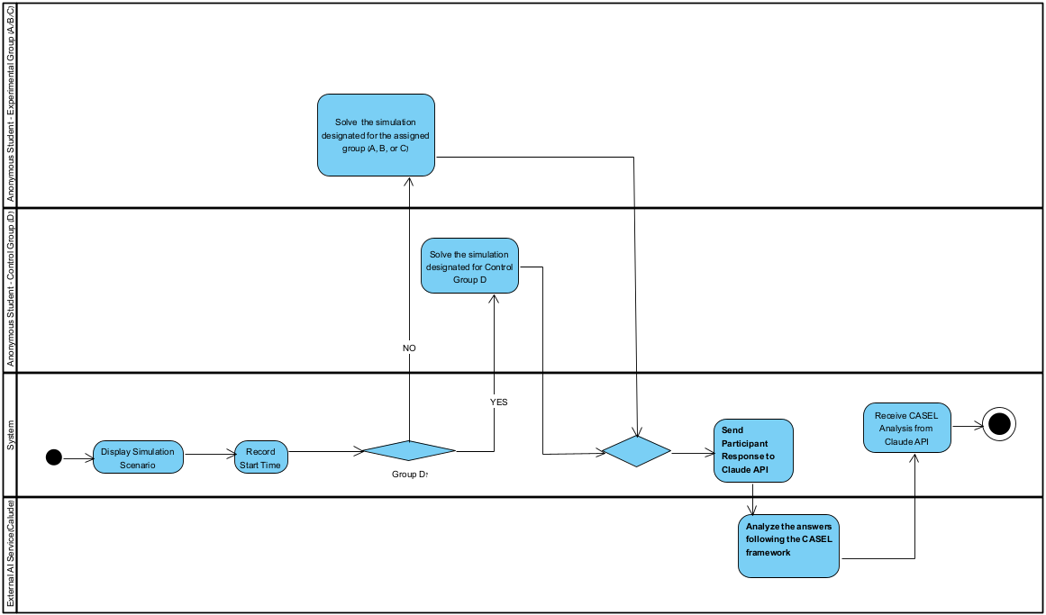
Figure 5. Simulation Execution and AI-Based CASEL Analysis Workflow

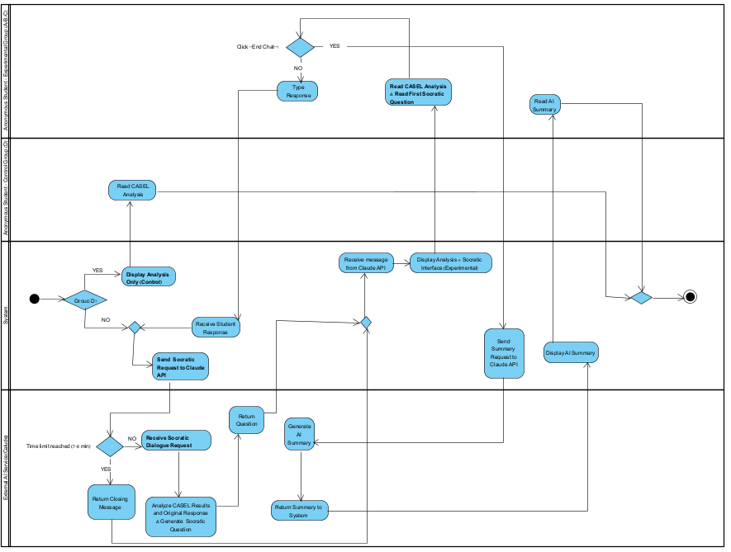
Figure 6. AI-Guided Socratic Dialogue and CASEL-Based Analysis Workflow
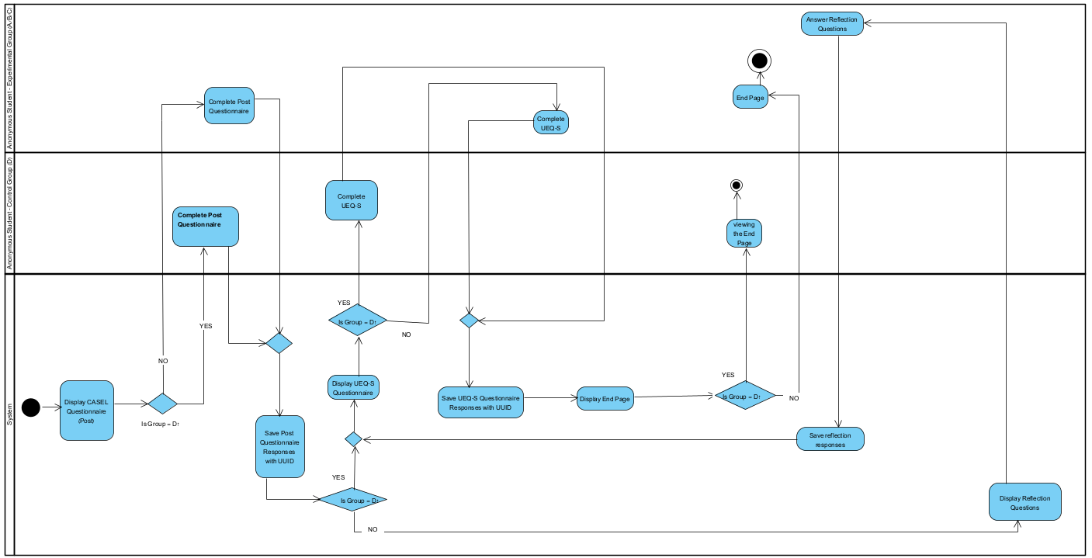
Figure 7. Post-Questionnaire, UEQ-S, Reflection, and Study Completion Workflow

Appendix H: AI Development Tools, Resources, and Prompt Engineering
This research was supported by the use of several AI-based tools. Claude was primarily used to assist with academic writing and content structuring, Perplexity was used to locate relevant academic literature in the field, ChatGPT was used for language refinement, editing, and content organization, and NotebookLM was used to generate diagrams and visual representations All tools were used solely as supportive aids, while all research, methodological, and interpretative decisions were carried out under our full responsibility.
ChatGPT Example Prompt :
“Please revise the following paragraph to improve academic tone, clarity, and coherence. Preserve the original meaning, avoid adding new content, and ensure consistency with formal research writing standards.”
NotebookLM Example Prompt :
“Based on the provided research phases and system development steps, generate a clear and structured diagram that visually represents the research engineering process, from requirements definition to experimental evaluation.”
Claude Example Prompt :
“Analyze the following research paper and extract the main findings, key theoretical concepts, and limitations related to Social-Emotional Learning (SEL). Emphasize aspects relevant to AI-guided or technology-supported interventions in higher education.”
Perplexity Example Prompt :
“Identify peer-reviewed academic articles on CASEL-based Social-Emotional Learning (SEL) in higher education. Focus on empirical studies, assessment methods, and recent publications within the last decade.”
Appendix I: Research Specific System Interfaces and Screenshots
This appendix includes a limited selection of screenshots from the system interface developed for the research. The purpose of these screenshots is to illustrate the implementation of the research ideas and theoretical principles discussed in the research chapters. Accordingly, the appendix presents a concise set of screenshots representing key system components only.
Figure 7 presents the socio-emotional simulation screen, where participants engage with a realistic academic scenario and provide an open-ended written response reflecting their emotional and cognitive processing.
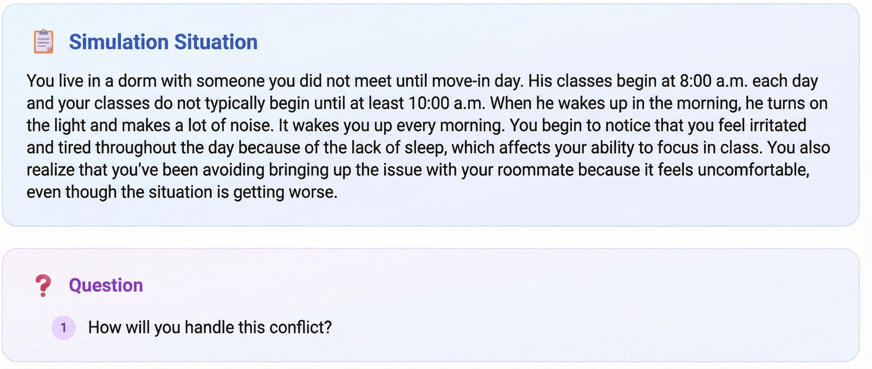
Figure 7: Example of a Socio Emotional Simulation Screen
Figure 8 Presents automated CASEL analysis with feedback, explanations, informing stages.
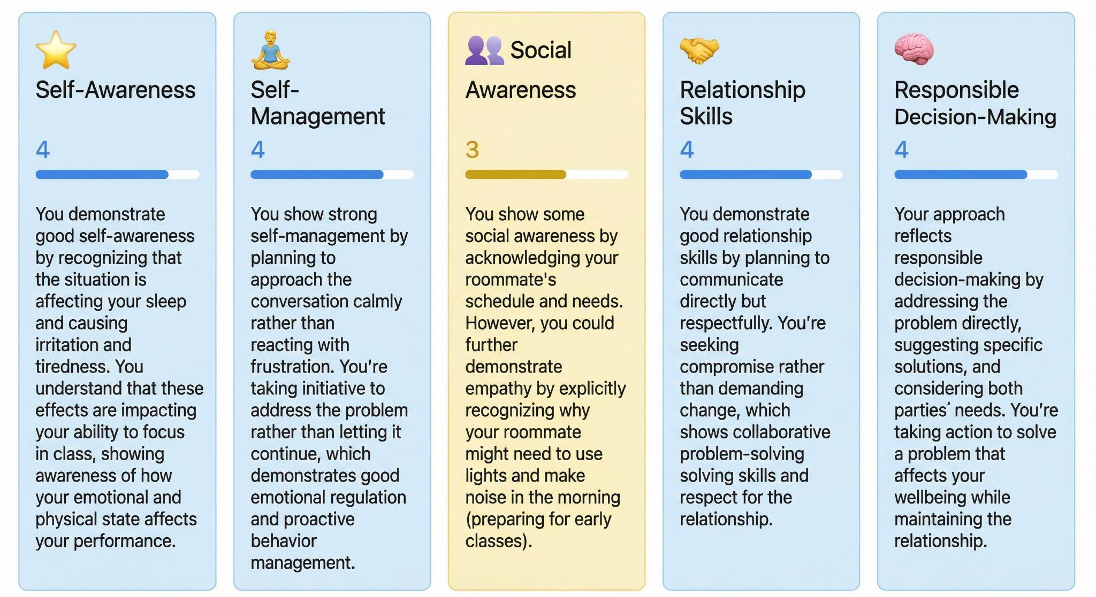
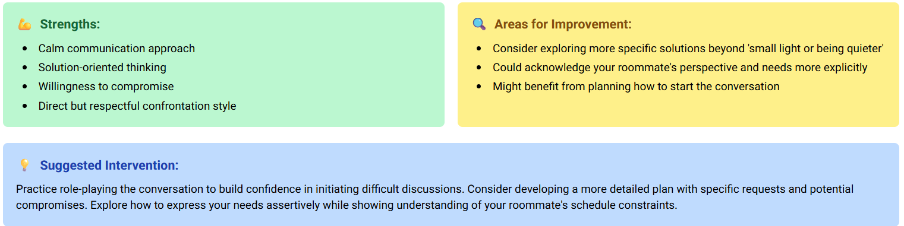
Figure 8: Example of AI-Generated CASEL Competency Analysis and Feedback
Figure 9 presents the AI guided Socratic dialogue module in CASELy, activated for the experimental groups following the simulation and automated CASEL analysis. The system conducts a brief reflective interaction using open ended questions grounded in participant input and analysis output, without providing advice or judgment, as part of a controlled and consistent intervention.
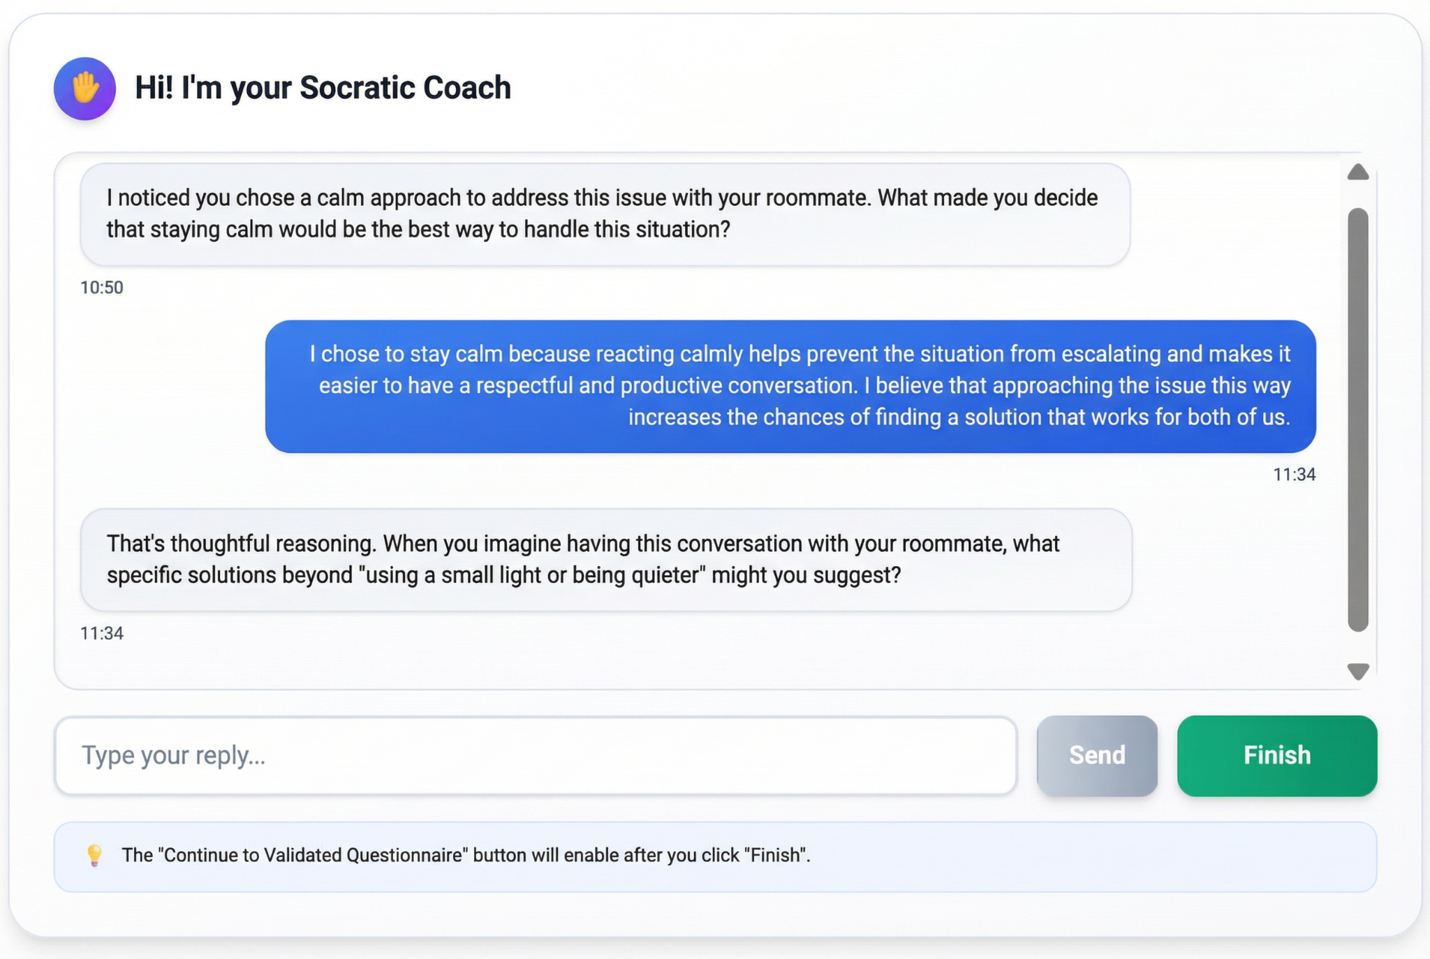
Figure 9: Example of AI-Guided Socratic Dialogue Screen

